Planning and Executing a Professional Learning Community (PLC) with Student Work Focus
PLC Scope and Sequence Guidance

At a time when few things about school remain certain, the one thing we can count on is that students will continue to complete tasks measuring their progress on material being taught in class. One of the ways we can best support our partners is to ensure that teacher and leader focus is directed towards student work. In order to effectively respond to student needs through timely feedback that makes an impact, teachers must analyze the tasks from pre-identified lessons focusing on the most important standards for the current unit of study. Leaders must create the conditions for teachers to gather—whether led by leaders or teacher leaders—to norm on the student tasks they will use to measure student progress. This document, in addition to the supplemental resources, can be shared with school leaders and teachers to support them in implementing ongoing student work focused PLCs in their virtual spaces or as a guide in the event there are limited contract hours for a content lead to execute.
PLC Cycle
The PLC cycle example listed below can be modified to fit school time constraints as long as all components are completed. Teachbacks and practice sessions can also be incorporated into the cycle as an additional component to a session or a standalone session.
Session 1: Getting Clear on Outcomes
- Understanding the Unit: Teachers get clear on the outcomes and critical standards for the unit of study by identifying the focus standards of the unit.
- Identifying the Lesson and Tasks: Identify the specific lessons and tasks that will be used to track student mastery throughout the unit. Teachers then identify the student work from the task they will use to track progress.
Session 2: Norming on Exemplar Response, Criteria for Mastery, and Instructional Moves
- Completing the Task: Each teacher comes to the PLC with their completed exemplar response.
- Norming on the Task: Teachers analyze qualities of each other's response and any exemplars provided to determine criteria for mastery.
- What are the instructional moves the teacher will make to support students in reaching mastery?

Session 3: Analyzing Work to Determine Feedback & Next Steps
- Analyze* student work to determine feedback and next steps for students who have not yet shown mastery and identify how students who improved mastery did so.
- Identify the upcoming task that will be used to gauge further student mastery improvement.
- Continue to repeat the cycle.
*In case PLC lead needs protocol for student work analysis

Planning for Student Work PLC

PLC Goal:
The goal of PLC is to ensure teachers have an opportunity to engage with both the content they are teaching and the student work completed as a result of that instruction.

Materials needed:
- Access to current unit, lessons, and tasks
- School calendar (with dates for PLC noted) and pacing calendars
- Student work for analysis
- PLC scope and sequence chart

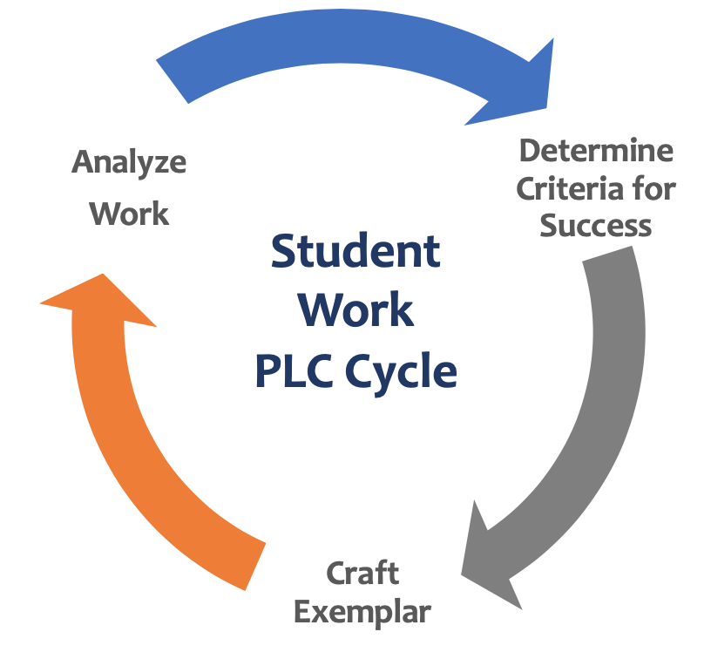
Example cycle:
- PLC 1: Determining outcomes
- PLC 2: Norming on exemplar, criteria for mastery
and instructional moves
- PLC 3: Analyze work to determine next steps
- PLC 4 and beyond: repeat cycle again!

Read this first: Explanations of scope and sequence headings
- Focus: What portion of the student work cycle are teachers engaging in to build their capacity?
- Practice protocol: What protocol will you use to make sure teachers have practice with the focus of the meeting?
- Progress monitoring: How will you progress monitor for this focus? Remember this should be clear to teachers by the end of the PLC.
- Pre-work: What do teachers need to do/bring to PLC to make sure every minute is used well? How will it be used in the PLC? How many days in advance will you communicate the pre-work? When will you remind people of the pre-work?

PLC Scope and Sequence for <INSERT SCHOOL, CONTENT, GRADES>

PLC Date | Focus | Practice Protocol | Progress Monitoring | Pre-work
Example:  XX/XX  45 minutes | Norming on Exemplar | Sharing exemplar responses | Identifying where teachers have shared criteria for mastery with students in preparation for task completion. | Preparing their own exemplar response ahead of the meeting.  - Email on XX  - Follow up on XX

About Instruction Partners
Instruction Partners works alongside educators to support great teaching, accelerate student learning, name and address unconscious bias, and ensure equitable access to great instruction—particularly for students in poverty, students of color, students learning English, and students with disabilities.

